DIS-AM,C-Taino-Pendant-Anthropomorphic owl

This pendant is made from manatee bone. Excessively large eyes may emphasize the Owls powers of vision. Human like hands rest under mouth and legs encircle the bottom of piece. The suspension holes are either side of mouth. On reverse is carved a simple bird head with swirling eyes, image 3. Measures 8.8cm or 3.4". Originally from the Dominican Republic. Dating c1000-1500AD.

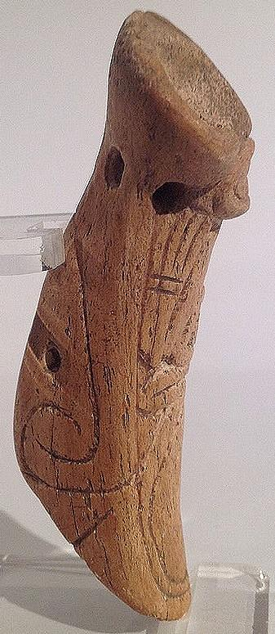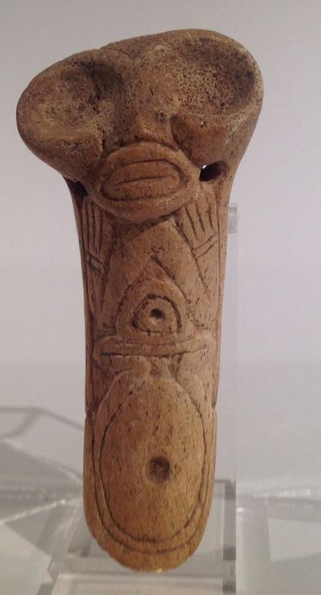 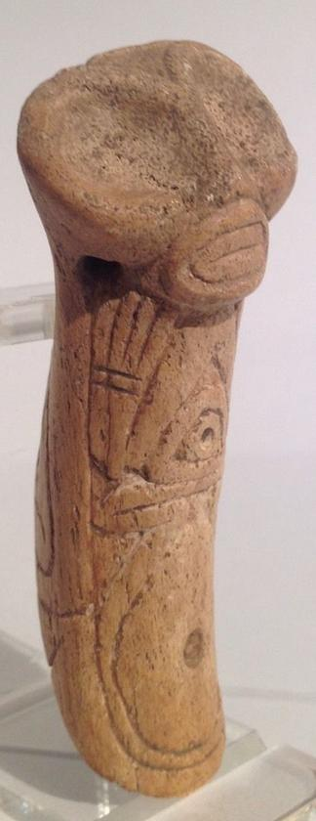 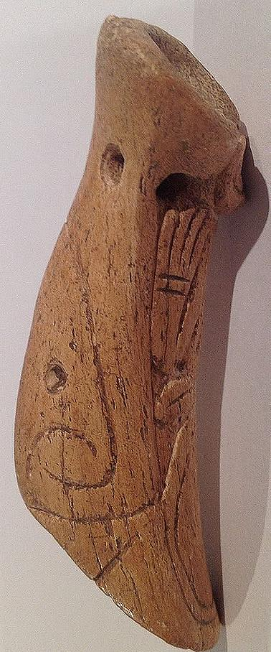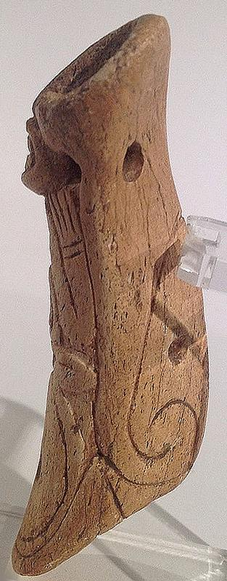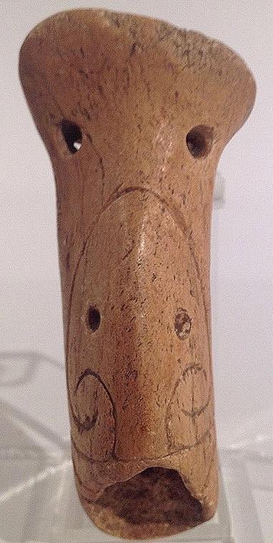

Sold by [flapast](http://myworld.ebay.com/flapast) ( [13303](http://feedback.ebay.com/ws/eBayISAPI.dll?ViewFeedback&userid=flapast) )

### Delivery package 1 of 1

Estimated delivery Monday, Jan 11, 2016

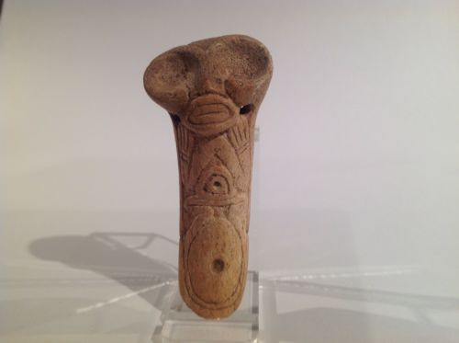

#### [Taino Large Owl-like Anthropic Transformation Pendant Pre Columbian](http://www.ebay.com/itm/252222346965)

|  |  |
| --- | --- |
| Item price | $75.00 |
| Quantity | 1 |
| Item number | 252222346965 |
| Shipping service | USPS First Class Package |

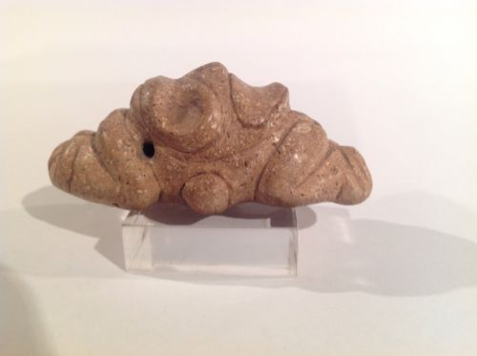

#### [Taino Zemi Like Stone Anthropic Pendant, Pre Columbian](http://www.ebay.com/itm/252222565480)

|  |  |
| --- | --- |
| Item price | $130.50 |
| Quantity | 1 |
| Item number | 252222565480 |
| Shipping service | USPS First Class Package |

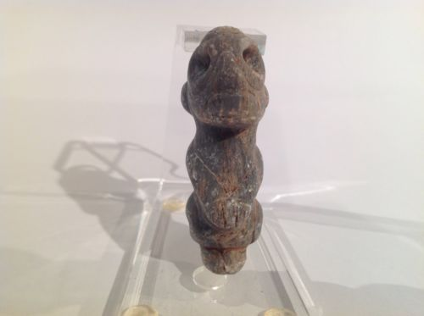

#### [Taino Marble Anthropic Pendant. Pre Columbian](http://www.ebay.com/itm/262204383837)

|  |  |
| --- | --- |
| Item price | $89.88 |
| Quantity | 1 |
| Item number | 262204383837 |
| Shipping service | USPS First Class Package |

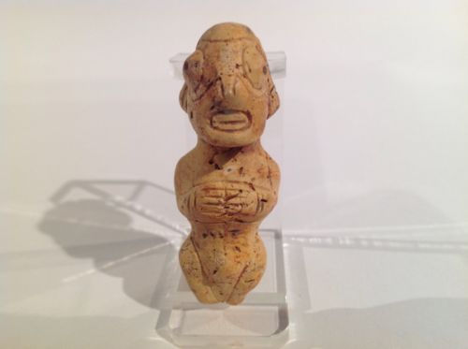

#### [Taino Stone Anthropic Pendant. Fertility Goddess Pre Columbian](http://www.ebay.com/itm/262204423416)

|  |  |
| --- | --- |
| Item price | $71.00 |
| Quantity | 1 |
| Item number | 262204423416 |
| Shipping service | USPS First Class Package |

## Sales order

Sold by [flapast](http://myworld.ebay.com/flapast) ( [13303](http://feedback.ebay.com/ws/eBayISAPI.dll?ViewFeedback&userid=flapast) )

### Delivery package 1 of 1

Estimated delivery Monday, Jan 11, 2016

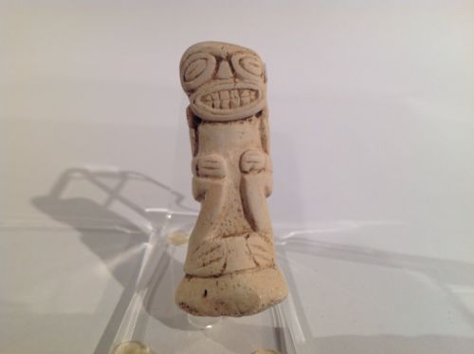

#### [Taino Full Figure Anthropic Figure, Pre Columbian](http://www.ebay.com/itm/252222452589)

|  |  |
| --- | --- |
| Item price | $89.00 |
| Quantity | 1 |
| Item number | 252222452589 |
| Shipping service | Economy Shipping |